Lab 4:
Prediction of future weather condition using Markov Chain
Objective:
To predict future weather condition using a Markov Chain based on given transition probabilities
Theory:
A Markov chain is a type of stochastic process in which probability of moving to the next state depends only on the present state and not on the sequence of past state. This property is known as Markov property. In weather prediction, the condition of a weather on future day depends only on a current weather condition. Each weather condition is treated as a state and the probability of transition from one state to another is represented by Transition Probability Matrix.
The future state of the system is calculated using the relation:
Xn+1 = Xn. P
Where Xn = current state vector
P = transition probability matrix
States of the system:
The weather condition are defined as :
Sunny ( S)
Rainy ( R)
Cloudy( C)
Transition Probability Matrix
The transition probability Matrix is :
P = [0.6 0.3 0.1]
[0.3 0.4 0.3]
[ 0.2 0.3 0.5]
Each row of the matrix represent the current weather condition and each column represents the next days weather condition. The sum of the probability in each row is equal to 1.
Algorithm:
- Define the weather state.
- Initialize the transition probability matrix.
- Define the initial state vector.
- Multiply the current state vector with the transition matrix.
- Repeat the process for the required number of days.
- Display the predicted weather probability.

Source Code:
#include <iostream>
#include <iomanip>
using namespace std;
int main()
{
float P[3][3] = {
{0.6, 0.3, 0.1},
{0.3, 0.4, 0.3},
{0.2, 0.3, 0.5}
};
float state[3] = {1, 0, 0}; // Sunny today
float nextState[3];
int days;
cout << "Enter number of days to predict: ";
cin >> days;
cout << fixed << setprecision(2);
for(int d = 1; d <= days; d++)
{
for(int i = 0; i < 3; i++)
{
nextState[i] = 0;
for(int j = 0; j < 3; j++)
{
nextState[i] += state[j] * P[j][i];
}
}
for(int i = 0; i < 3; i++)
state[i] = nextState[i];
cout << "\nDay " << d << " Prediction:\n";
cout << "Sunny : " << state[0] * 100 << "%\n";
cout << "Cloudy : " << state[1] * 100 << "%\n";
cout << "Rainy : " << state[2] * 100 << "%\n";
}
return 0;
}

Output:
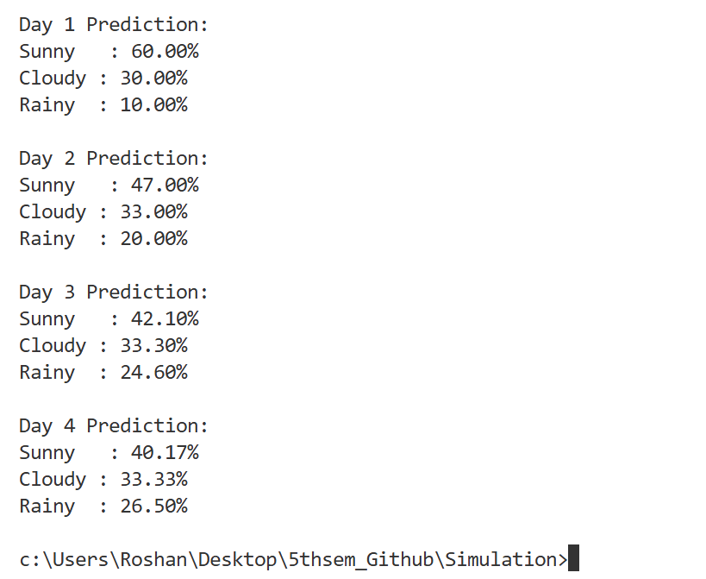
Result:
The future weather condition were successfully predicted for the given number of days using the Markov chain model.
Conclusion:
This experiment shows that Markov chain is an effective mathematical tool for predicting future weather conditions. Since, the model follows the Markov property, the prediction depends only on the present state, making it suitable for weather forecasting and similar real world application.

